**Report on Assignment 2:**

1. Does your program output any garbage? If yes, why?

Although the values printed are not necessarily garbage, the program outputs the values from the producer as not desired.

Since the output is not desired we may safely assume that garbage values are printed by the consumer.

1. Are all the produced values getting consumed? Check your program for a small count like 20.

The system prints all the produced values first and then the consumer prints the **last** **value** “count” number of times.

This happens due to the produce program being called first and then the consume program – from the shell command:

**resume( create(producer, 1024, 20, "producer", 1, count) );**

**resume( create(consumer, 1024, 20, "consumer", 1, count) );**

The above things are not synchronized and hence the global variable n is set completely to the maximum value which is the value in “count” by the producer.

By the time the consumer is started, the value of n would have been set to the last value by the producer and hence the consumer prints only the last assigned value of n which is count itself (as per the requirement).

Below is the screen print of the output:

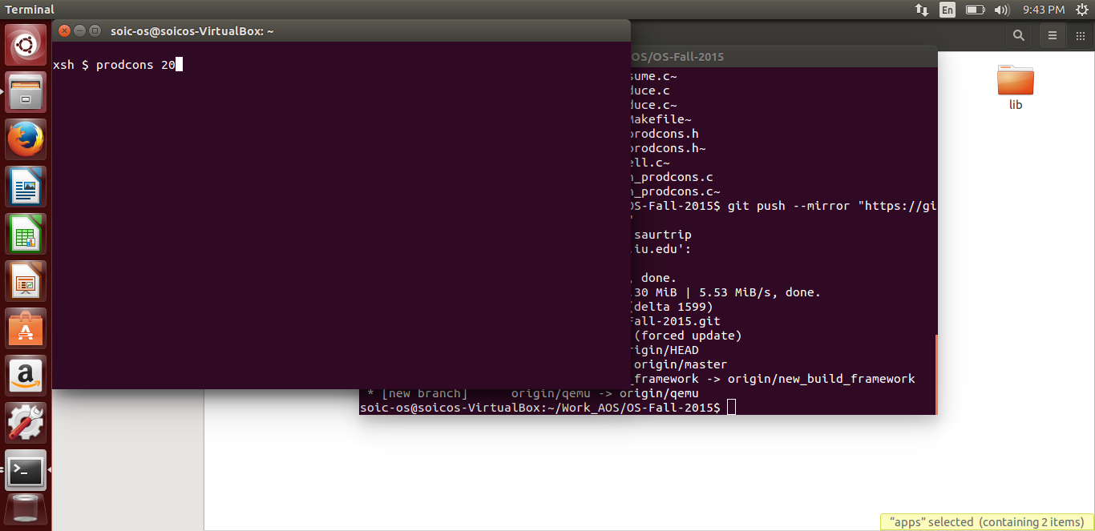

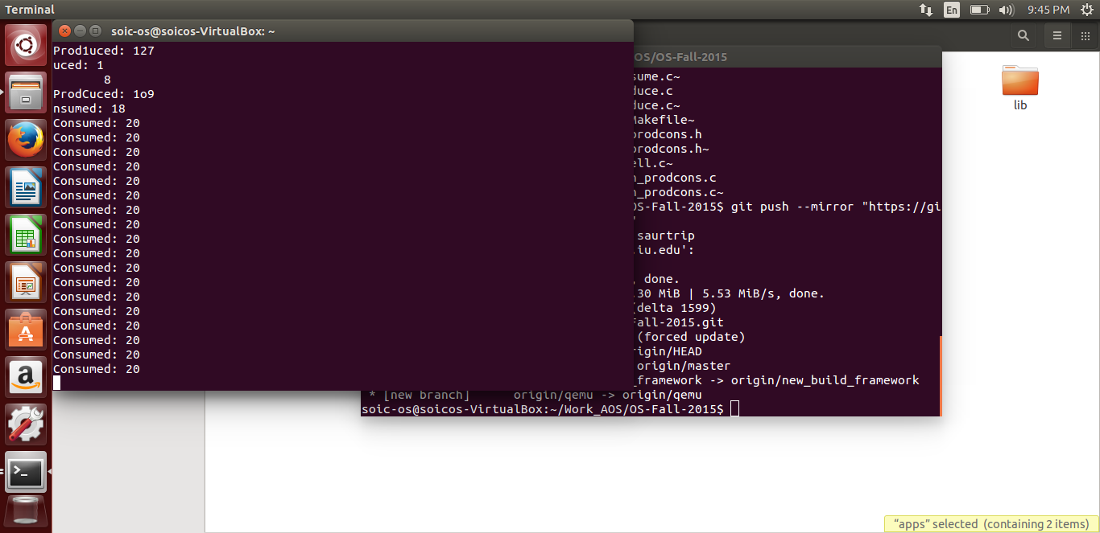

Functions used:

(), create(), resume() - given

Producer() – Saurabh

Consumer - Shree